Positive Behavior Interventions and Supports PBIS
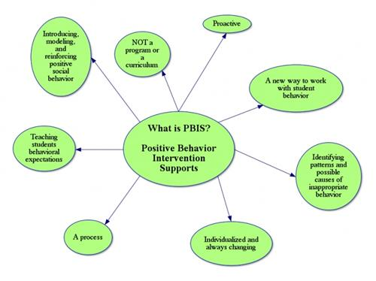
Stevens Child Care locations were first introduced to PBIS methods and resources in 2009. In 2015 we became part of a PBIS support system with Chester Elwyn Seeds. As a result of this we learned more about resources, methods, trainings and supports through meetings, trainings and program wide support from the PBIS team in Chester Seeds.We were assigned a Coach D. Bobo-Carter. The coach kept us informed and on task with the organized implementation of P.B.I.S. We were able to begin being observed and scored for our fidelity in the practice of implementing P.B.I.S.. As a result of this we have maintained fidelity in our practice of P.B.I.S. since 2016.
The websites below are valuable resources that we are sharing to help families gain a deeper understanding about PBIS.

https://www.pbis.org/topics/early-childhood-pbis

http://csefel.vanderbilt.edu/

